DBS301 DE Lab 8 – MUHAMMAD AHMED – SENECA ID 126330166 – SECTION D.
PROF.NEBPJSA CONKIC

Due by Wednesday, March 27th by 3pm

You will create table MY_EMP by using this chart

Id NUMBER(4) NOT NULL
Last_Name VARCHAR2(25)
First_Name VARCHAR2(25)
User_Id VARCHAR2(8)
Salary NUMBER(9,2)

To begin this lab you must have table MY_EMP as an empty table.

1. Add 4 rows to table MY_EMPL as following by using INSERT statement without column names (Dunn&Hong will have NO salary for now).

150 Popov Olga opopov 8500
160 Benson Jane jbenson 11000
170 Dunn David ddunn
180 Hong Tom thong

INSERT INTO MY_EMP VALUES(
'160', 'Popov', 'Olga', 'opopov', '8500');

INSERT INTO MY_EMP VALUBES(
'160', 'Benson', 'Jane', 'jbenson', '11000');

INSERT INTO MY_EMP VALUES(
'170','Dunn', 'David', 'ddunn', '');

INSERT INTO MY_EMP VALUES(
'180', 'Hong', 'Tom', 'thong', '');

Add 2 more rows as following, where Rita will NOT have salary assigned yet. Use INSERT statement with column names.

110 Preston Scott spreston 7000
120 Gomez Rita rgomez

SAVE your transaction and verify what is stored in your table MY_EMP.

INSERT INTO MY_EMP VALUES(
'110','Preston','Scott', 'spreston', '7000');

INSERT INTO MY_EMP VALUES(
'120','Gomez','Rita','rgomez', '');

SELECT * FROM MY_EMP;
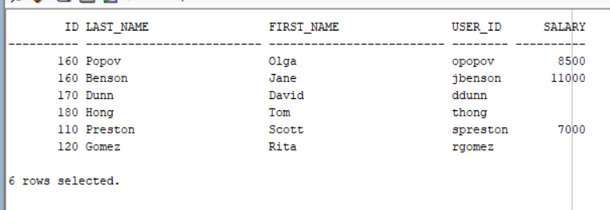

2. Populate your table MY_EMP by inserting rows from table EMPLOYEES under condition that only Representatives are inserted i.e people who have REP (or Rep) in their job title. It is up to you to determine which syntax option will achieve this task.
Assume that column User_Id may be populated with the same generic value called ‘generic’ (for all employees who do not have User_Id assigned yet).

Place a savepoint called NEW here. Verify what is stored in your table MY_EMP.

INSERT INTO MY_EMP (ID, FIRST_NAME, LAST_NAME, USER_ID, SALARY)
SELECT EMPLOYEE_ID, FIRST_NAME, LAST_NAME, email, SALARY
FROM EMPLOYEES
WHERE JOB_ID LIKE('%REP%');
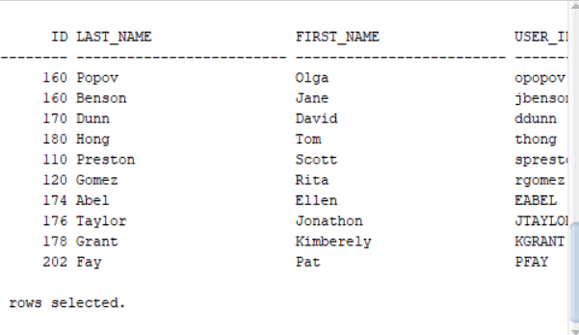

3. You will change last name and salary for employee Gomez (who was without pay) to become Jones with earning of $9000.

UPDATE MY_EMP
SET LAST_NAME = 'Jones', SALARY = 9000
WHERE LAST_NAME LIKE 'Gomez';

Now modify salaries in table MY_EMP for all employees who earn less than $9000 and give them increase of $2000.

UPDATE MY_EMP
SET SALARY = SALARY + 2000
WHERE SALARY < 9000;

Place a savepoint called OLD here. Verify what is stored in your table MY_EMP.

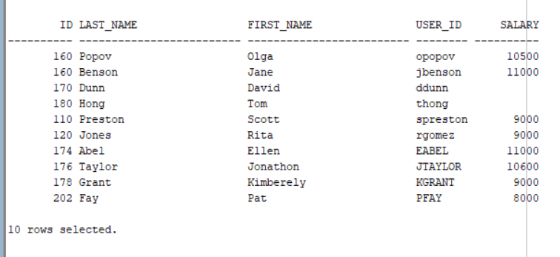

4. Remove all employees from MY_EMP who earn more than Ernst (in table EMPLOYEES).
DELETE FROM MY_EMP
WHERE SALARY > (SELECT SALARY FROM EMPLOYEES
WHERE LAST_NAME = 'Ernst');
Create savepoint called ONE and verify what is stored in your table MY_EMP.
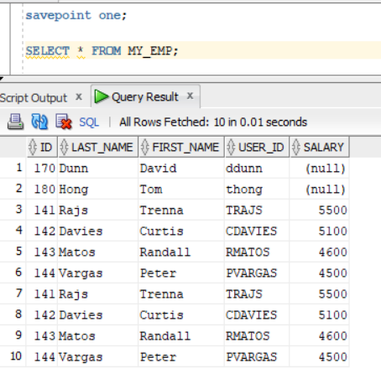

5. Now modify salaries for all employees who earn more than POPOV (in table MY_EMP), so that they get deduction of $1000. Verify what is stored in your table MY_EMP.

UPDATE MY_EMP
SET SALARY = SALARY - 1000
WHERE SALARY > (SELECT SALARY FROM MY_EMP
WHERE LAST_NAME =’PAPOV’;
6. Go back to your position OLD now (discard everything that happened after that).
Then remove all employees from MY_EMP whose Id is greater than 150..
Finally save your changes and show content of table MY_EMP.
delete from my_emp
where id > 150;

